**Accident Witness Form**

In the event of an accident, each passenger should be documented on this form. Specify the location of the passenger by placing the corresponding witness numbers on the vehicle diagram in the proper location. The driver is responsible for obtaining this information from passengers and relaying it to the management personnel working the accident.

**Vehicle #: Sedan**

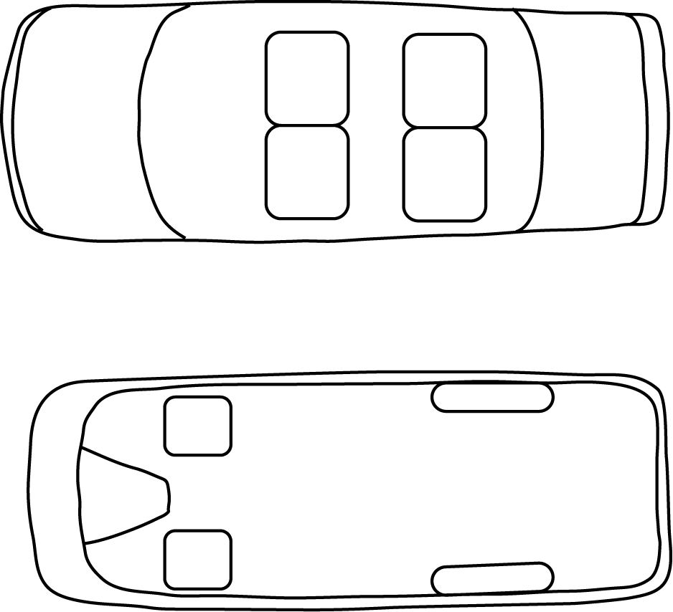

**Driver:**

**Date:**

**Witness #1**

Name

Phone **Cargo Van**

Injury

**Witness #2**

Name

Phone

Injury

**Witness #3**

Name

Phone

Injury

**Witness #4**

Name

Phone

Injury

**Witness #5**

Name

Phone

Injury

**Witness #6**

Name

Phone

Injury

**Witness #7**

Name

Phone

Injury

**Witness #8**

Name

Phone

Injury